Lab 8 TASKS
24K-0559
BAZIL – UDDIN – KHAN

Q1).
CODE:
#include <iostream>
using namespace std;

class Node
{
public:

string Data;
Node * LeftChild;
Node * RightChild;

Node(string data)
{
Data = data;
LeftChild = nullptr;
RightChild = nullptr;
}

};

class FamilyAnsectorTree
{

public:
Node * Root;
FamilyAnsectorTree()
{
Root = nullptr;
}

void SetRoot(Node *r)
{
Root = r;
}

void PrintYoungest(Node * Root)
{
if(Root == nullptr)
{
return;
}

cout << " Youngest " << Root->Data << endl;
}

int HeightOfTree(Node * root)
{
if(root == nullptr)
{
return 0;
}
else
{
int heightr = HeightOfTree(root->RightChild);
int heightl = HeightOfTree(root->LeftChild);
if(heightr > heightl)
{
return heightr+1;
}
else
{
return heightl + 1;
}
}
}

void LeafNodesPrint(Node * Root)
{
if(Root == nullptr)
{
return ;
}

if(Root->LeftChild == nullptr && Root->RightChild == nullptr)
{
cout << " Data "<< Root->Data << endl;
return;
}
LeafNodesPrint(Root->LeftChild);
LeafNodesPrint(Root->RightChild);

}

void PrintLevelOfEach(Node * Root,int level)
{
if(Root == nullptr)
{
return;
}
cout << Root->Data << " is at level " << level << endl;
PrintLevelOfEach(Root->LeftChild, level + 1);
PrintLevelOfEach(Root->RightChild, level + 1);
}

};

int main()
{
FamilyAnsectorTree family;

Node * john = new Node("John");
Node * mary = new Node("Mary");
Node * david = new Node("David");
Node * anna = new Node("Anna");
Node * tom = new Node("Tom");
Node * susan = new Node("Susan");
Node * robert = new Node("Robert");

john->LeftChild = mary;
john->RightChild = david;

mary->LeftChild = anna;
mary->RightChild = tom;

david->LeftChild = susan;
david->RightChild = robert;

family.SetRoot(john);
family.PrintYoungest(family.Root);

cout << " Leaf nodes ancestors with no known parents : " << endl;
family.LeafNodesPrint(family.Root);

cout << " Height of the tree: " << family.HeightOfTree(family.Root) << endl;

cout << "Level of each member: " << endl;
family.PrintLevelOfEach(family.Root, 0);

return 0;
}

OUTPUT:
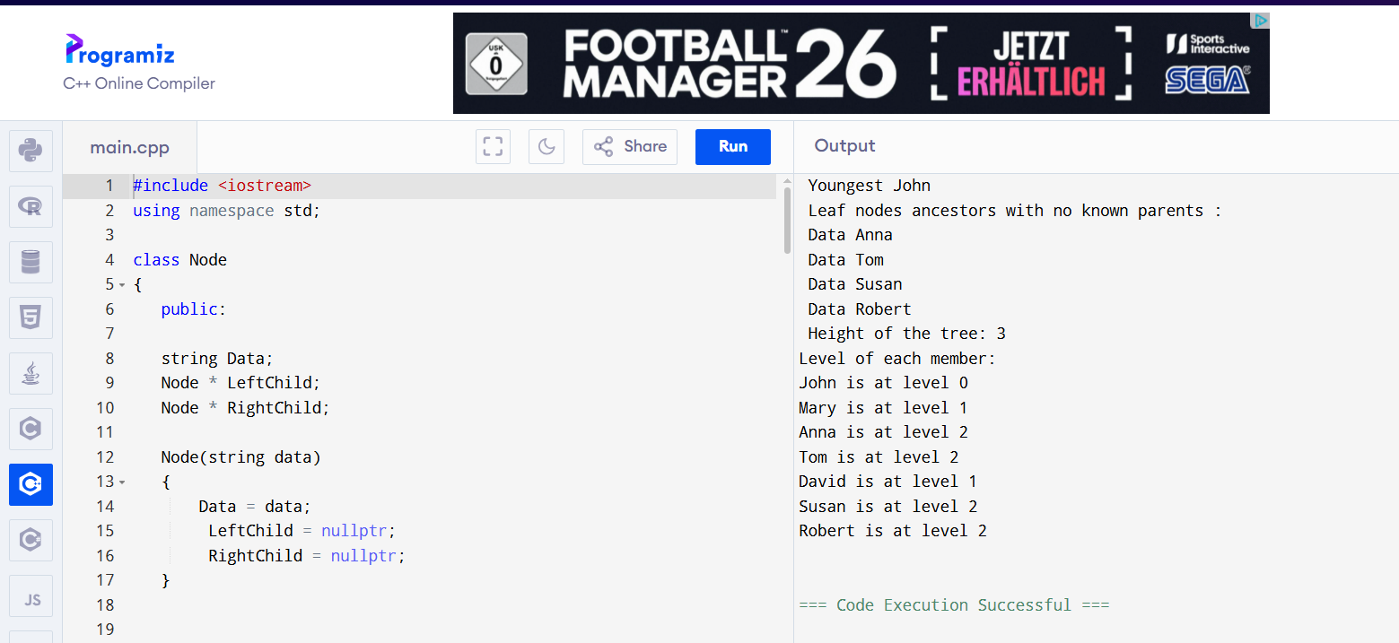

Q2).
CODE:
#include <iostream>
using namespace std;

class Node
{
public:

string Data;
int PlayCounts;
Node * LeftChild;
Node * RightChild;

Node(string data, int count)
{
Data = data;
PlayCounts = count;
LeftChild = nullptr;
RightChild = nullptr;
}

};

class MusicBst
{

public:
Node * Root;

MusicBst()
{
Root = nullptr;
}

Node * InsertNode(Node * root,Node * newnode)
{
if(root == nullptr)
{
root = newnode;
return root;
}

if(newnode->PlayCounts < root->PlayCounts)
{
root->LeftChild = InsertNode(root->LeftChild,newnode);
}

else if (newnode->PlayCounts > root->PlayCounts)
{
root->RightChild = InsertNode(root->RightChild,newnode);
}

return root;
}

Node * SearchSong(int count,Node * Root)
{
if(Root == nullptr)
{
return nullptr;
}

if(Root->PlayCounts == count)
{
cout << " song : "<< Root->Data << " Total Times Played " << count << endl;
return Root;
}

else if(Root->PlayCounts > count )
{

return SearchSong(count,Root->LeftChild);
}

else
{
return SearchSong(count,
Root->RightChild);
}
}

void InOrder(Node * Root)
{
if(Root == nullptr)
{
return ;
}

InOrder(Root->LeftChild);
cout << " " << Root->Data << " "<< "("<<Root->PlayCounts << ") ";
InOrder(Root->RightChild);
}

void PostReverseInOrder(Node * Root)
{
if(Root == nullptr)
{
return ;
}

PostReverseInOrder(Root->RightChild);
PostReverseInOrder(Root->LeftChild);
cout << " " << Root->Data << " "<< "("<<Root->PlayCounts << ") ";

}

Node * min(Node * root)
{
if(root == nullptr)
{
return nullptr;
}
else if(root->LeftChild != nullptr)
{
return min(root->LeftChild);
}
else
{
return root;
}
}

Node * DeleteSong(Node * root,int count)
{
if(root == nullptr)
{
return nullptr;
}

if(count < root->PlayCounts)
{
root->LeftChild = DeleteSong(root->LeftChild,count);
}
else if(root->PlayCounts < count)
{
root->RightChild = DeleteSong(root->RightChild,count);
}

else
{
if(root->LeftChild == nullptr && root->RightChild == nullptr)
{
delete root;
return nullptr;

}

else if(root->RightChild == nullptr)
{
Node * temp = root->LeftChild;
delete root;
return temp;

}

else if(root->LeftChild == nullptr)
{
Node * temp = root->RightChild;
delete root;
return temp;

}
else
{
Node * bode = min(root->RightChild);
root->Data = bode->Data;
root->PlayCounts = bode->PlayCounts;
root->RightChild = DeleteSong(root->RightChild,bode->PlayCounts);

}

}
return root;

}

};

int main()
{
MusicBst bst;

bst.Root = bst.InsertNode(bst.Root, new Node("SongA", 50));
bst.Root = bst.InsertNode(bst.Root, new Node("SongB", 20));
bst.Root = bst.InsertNode(bst.Root, new Node("SongC", 70));

bst.SearchSong(50, bst.Root);

cout << "Inorder: ";
bst.InOrder(bst.Root);
cout << endl;

cout << "Postorder: ";
bst.PostReverseInOrder(bst.Root);
cout << endl;

bst.Root = bst.DeleteSong(bst.Root, 20);
cout << "After delete: ";
bst.InOrder(bst.Root);
cout << endl;

return 0;
}

OUTPUT:
